|  |  |
| --- | --- |
| Bankruptcy Status Total: | Data Workflow |

Random Forest Score

| Row ID | TruePositives | FalsePositives | TrueNegatives | FalseNegatives | Recall | Precision | F-measure | Accuracy |
| --- | --- | --- | --- | --- | --- | --- | --- | --- |
| 1 | 3674 | 0 | 31 | 230 | 0.9410860655 | 1 | 0.9696489839 |  |
| 0 | 31 | 230 | 3674 | 0 | 1 | 0.1187739463 | 0.2123287671 |  |
| Overall |  |  |  |  |  |  |  | 0.9415501905 |
|  |  |  |  |  |  |  |  |  |

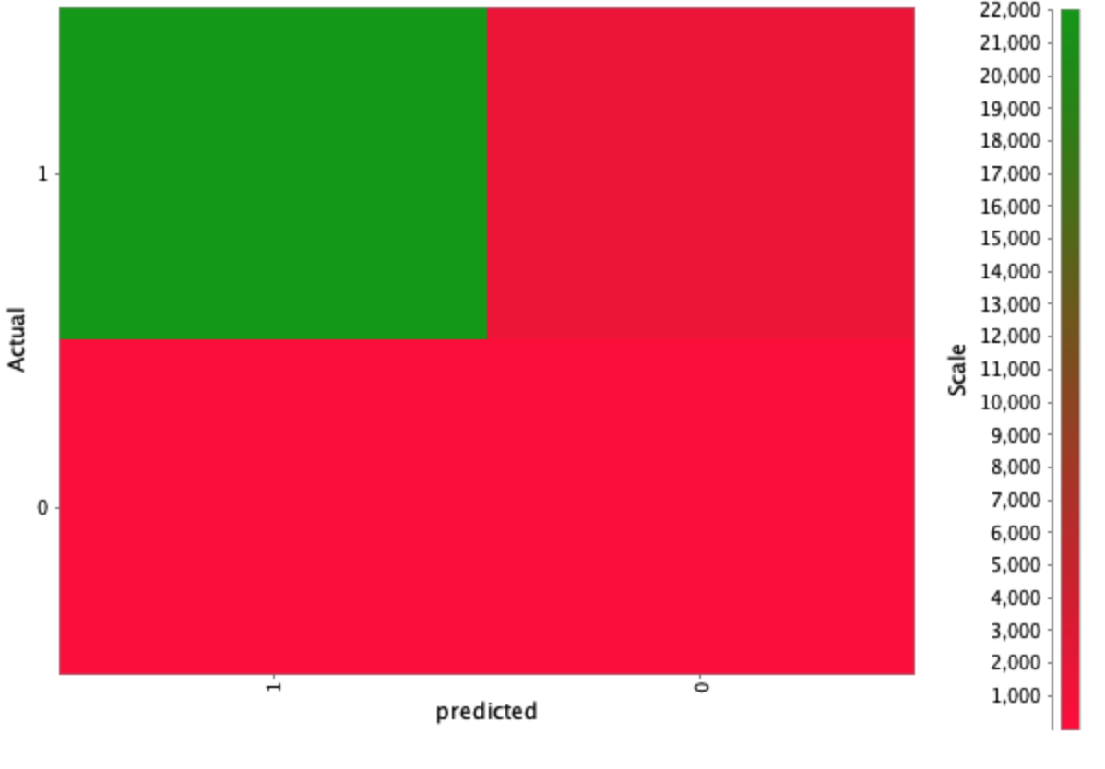

Decision Tree Score

| Row ID | TruePositives | FalsePositives | TrueNegatives | FalseNegatives | Recall | Precision | F-measure | Accuracy |
| --- | --- | --- | --- | --- | --- | --- | --- | --- |
| 1 | 3674 | 232 | 29 | 0 | 1 | 0.9406041986 | 0.9693931398 |  |
| 0 | 29 | 0 | 3674 | 232 | 0.1111111111 | 1 | 0.1999999999 |  |
| Overall |  |  |  |  |  |  |  | 0.9410419313 |
|  |  |  |  |  |  |  |  |  |

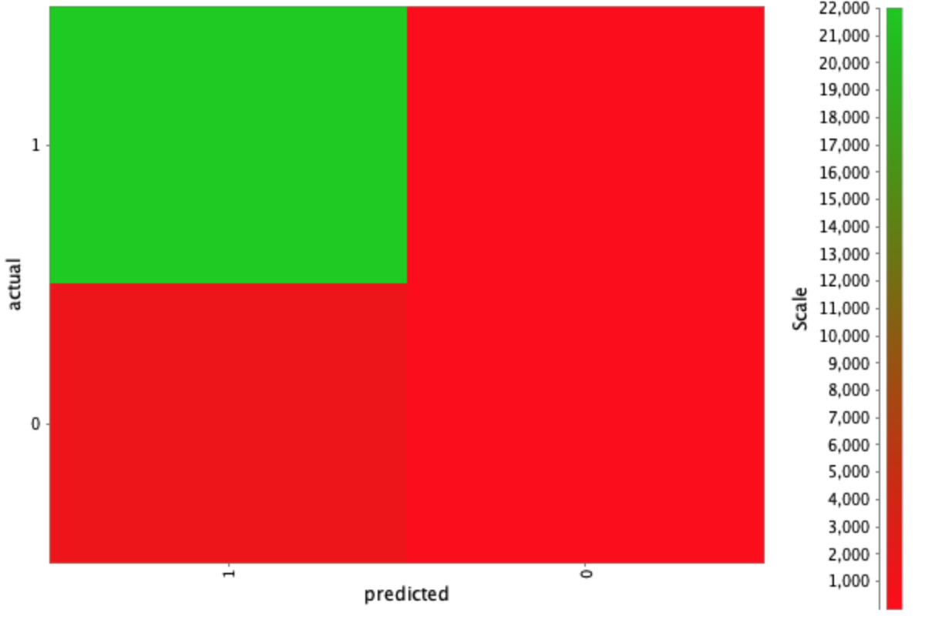

Tree Ensemble Score

| Row ID | TruePositives | FalsePositives | TrueNegatives | FalseNegatives | Recall | Precision | F-measure | Accuracy |
| --- | --- | --- | --- | --- | --- | --- | --- | --- |
| 1 | 3670 | 251 | 10 | 4 | 0.9989112683 | 0.9359857179 | 0.9664252797 |  |
| 0 | 10 | 4 | 3670 | 251 | 0.0383141762 | 0.7142857142 | 0.0727272727 |  |
| Overall |  |  |  |  |  |  |  | 0.9351969504 |
|  |  |  |  |  |  |  |  |  |

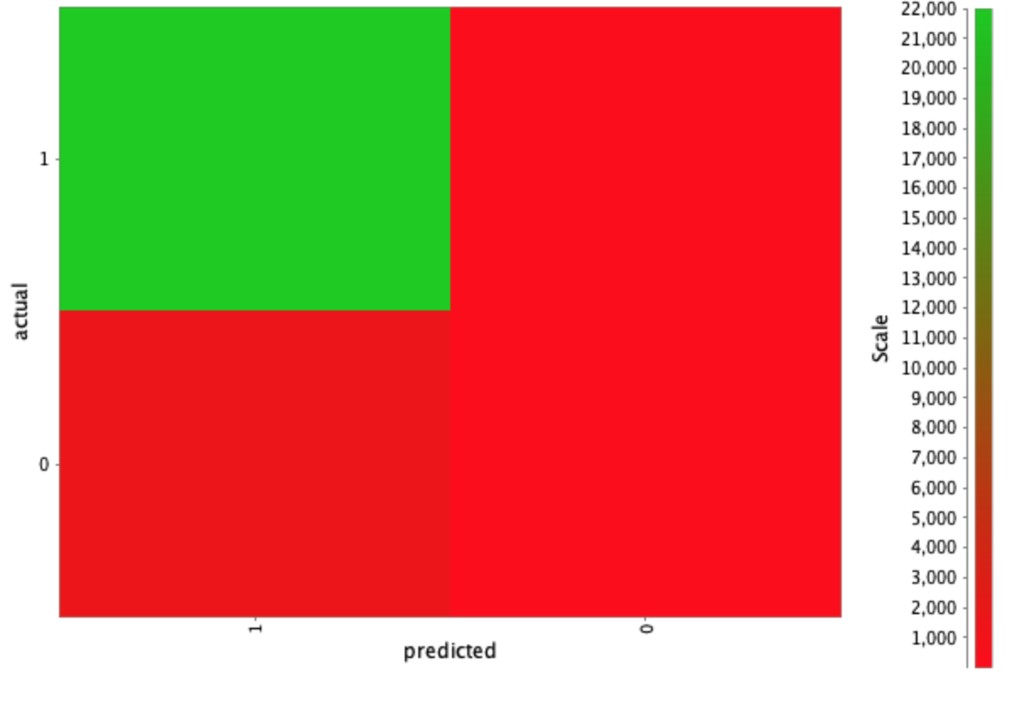

Gradient Boosted Trees Score

| Row ID | TruePositives | FalsePositives | TrueNegatives | FalseNegatives | Recall | Precision | F-measure | Accuracy |
| --- | --- | --- | --- | --- | --- | --- | --- | --- |
| 1 | 3673 | 260 | 1 | 1 | 0.9997278170 | 0.9338927027 | 0.9656894965 |  |
| 0 | 1 | 1 | 3673 | 260 | 0.0038314176 | 0.5 | 0.0076045627 |  |
| Overall |  |  |  |  |  |  |  | 0.9336721728 |
|  |  |  |  |  |  |  |  |  |

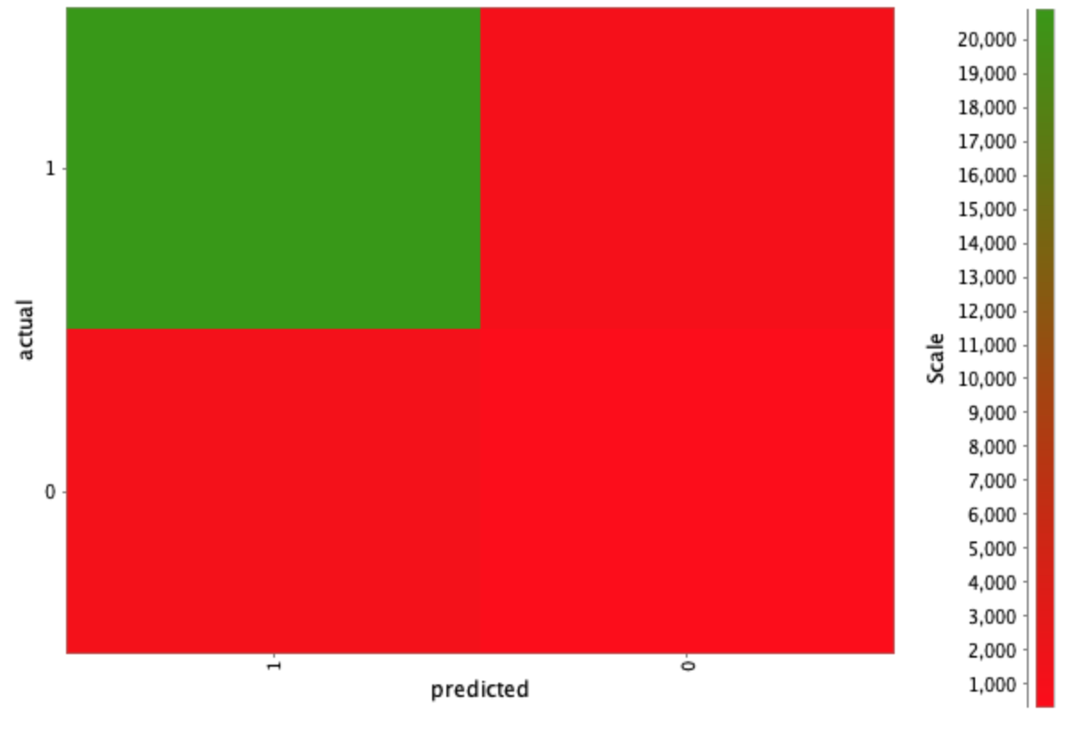

Logistic Regression Score

| Row ID | TruePositives | FalsePositives | TrueNegatives | FalseNegatives | Recall | Precision | F-measure | Accuracy |
| --- | --- | --- | --- | --- | --- | --- | --- | --- |
| 1 | 3504 | 204 | 57 | 170 | 0.9537289058 | 0.9449838187 | 0.9493362232 |  |
| 0 | 57 | 170 | 3504 | 204 | 0.2183908045 | 0.2511013215 | 0.2336065573 |  |
| Overall |  |  |  |  |  |  |  | 0.9049555273 |
|  |  |  |  |  |  |  |  |  |

